1. (a) Create an anonymous function for  and use it to graph the interval 0 ≤ x ≤ 2.
2. Create an anonymous function of  and use it draw the function for the interval 0 ≤ x ≤ 0.2, with the step 0.01 and find where the f(x)=0 is approximated.
3. 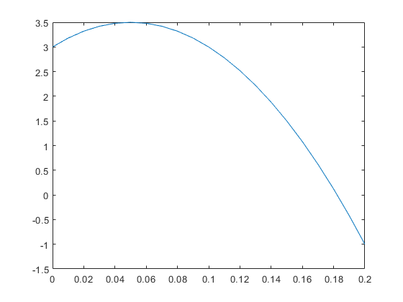Use the “fzero” function to accurately find the position of the f(x)=0 of the function in (b).

x=0:0.01:0.2;

y=(20.*x)-200.*(x.^2)+3;

plot(x,y)

1. The table below shows the hourly wages, worked hours, and output (number of products) for five product operators (產品作業員) in a week.



Use MATLAB to answer the following questions:

a. How much salary did each worker earn this week?

b. What is the total salary paid?

c. How many units are manufactured?

d. What is the average cost per unit of output?

e. How many hours does it take on average to produce a product?

f. Assuming that each operator produces the same quality product, which operator is the most efficient? And which one is the most inefficient?

1. A fenced enclosed area consists of a rectangle of length L and width 2R, and a semicircle of radius R, as shown in Figure P.4. The area A of this enclosed area is 2000 square feet. Fence costs $50 per foot for curved sections and $40 per foot for straight sections. Use the “fminsearch” function to determine R and L that minimize the cost of fencing at a resolution of 0.01 feet. Also calculate the minimum cost.

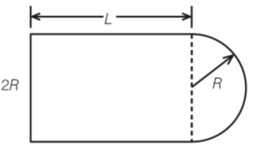

Fig P.4

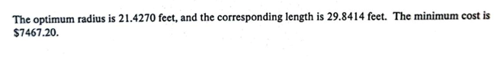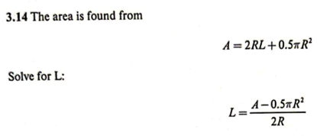

1. Write a MATLAB SUB-function (*.m) to evaluate the members of the sequence, where a, and n are the inputs and the sequence value of is the output of this SUB-function and save it as a script file. Then, write a main function to input the range of the value n from 0 to 20, and =2, and call the SUB-function to evaluate the sequence value, and display the value of n and by using “*fprintf”*, as the following format:

n 

1. 2
2. 4
3. 4
4. 8/3
5. In MATLAB, input the following matrix, and use this matrix to answer the following questions.

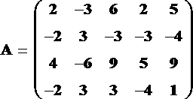

1. Construct a 4x3 matrix B, its elements is the third column through 5th column of A
2. Construct a 2x5 matrix C, its elements is the second row through 4th row of A
3. Construct 2×3 matrix D, its elements is the first two rows and the last three columns of A

6.

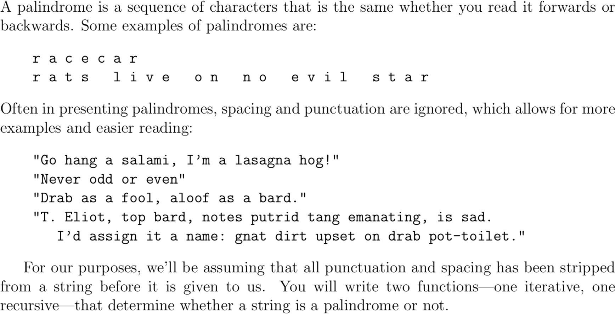

Write a recursive function to check a palindrome. function is_

pal = pal1(str)